Copulas: EURUSD and USDCHF
Method 18 / daily log returns / empirical ranks / Gaussian + Clayton / Alpari D1 full available history

Study setup
Logical pair: EURUSD , USDCHF
Broker symbols: EURUSD_i , USDCHF_i
Snapshot: 2026-11-03_majors_alpari_D1
Timeframe: D1
Matched return window: 1999-01-05 to 2026-11-02 (UTC bar dates)
Matched return count n: 7186
Dropped unfinished last bar dated 2026-11-03 UTC after a tick-volume check against the prior complete day.
Margins: empirical ranks / (n+1)
Families: Gaussian (rho) and Clayton (theta), fixed before ranking
Complete matched rows (Excel): EURUSD-USDCHF_Copula_D1.xlsx
Complete matched rows (HTML table): EURUSD-USDCHF_Copula_D1_data.html

Method carried forward
Copulas separate marginal return shapes from dependence on the unit square. Matched daily log returns of close, ln(close_t / close_t-1), are mapped to pseudo-observations u_i = rank(x_i)/(n+1) and v_i = rank(y_i)/(n+1). A Gaussian copula parameter rho is the Pearson correlation of Phi^{-1}(u) and Phi^{-1}(v). A Clayton copula theta >= 0 is fit by maximum likelihood on (u,v) for lower-tail asymmetry. Quotes are not inverted. Kendall tau implied by each fit and Spearman of (u,v) are stored. Same-sample Pearson r on returns is a side check. This is not causation and not a trading signal.

Results
Gaussian rho: -0.828593
Gaussian Kendall tau: -0.621717
Clayton theta: 0.000000
Clayton Kendall tau: 0.000000
Spearman of (u,v): -0.823916
Pearson r on returns: -0.749204

Conclusion
Over 7186 matched daily rows for EURUSD and USDCHF, Gaussian copula rho = -0.8286 (Kendall=-0.6217) and Clayton theta = 0.0000 (Kendall=0.0000). Spearman of (u,v) = -0.8239; Pearson r on returns = -0.7492. This is not causation and not a trading signal.

Charts
Daily closes

Daily log returns

Pseudo-observations (u,v)
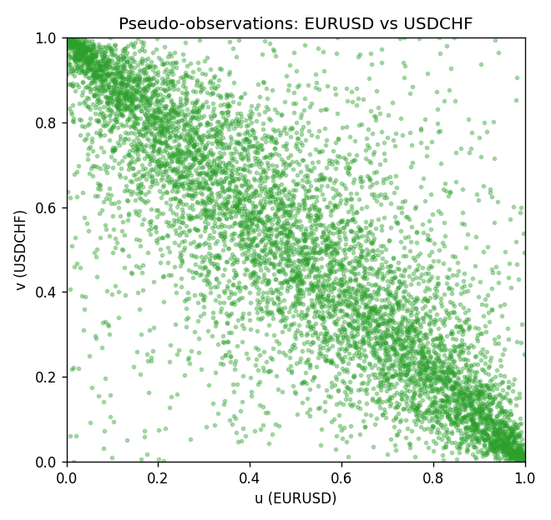

Data report
Every matched row is stored in the sibling Excel workbook named EURUSD-USDCHF_Copula_D1.xlsx, including u and v. Embedding all rows as a Word table is impractical; this file holds column summaries and the first and last 15 matched rows.
Columns: time, EURUSD_open, USDCHF_open, EURUSD_high, USDCHF_high, EURUSD_low, USDCHF_low, EURUSD_close, USDCHF_close, EURUSD_tick_volume, USDCHF_tick_volume, EURUSD_spread, USDCHF_spread, EURUSD_real_volume, USDCHF_real_volume, EURUSD_log_return, USDCHF_log_return, u, v
Column summaries (matched calculation rows)
column | count | mean | std | min | 25% | 50% | 75% | max
EURUSD_open | 7186 | 1.181536 | 0.15083018 | 0.8272 | 1.086205 | 1.16621 | 1.29401 | 1.5995
USDCHF_open | 7186 | 1.0974503 | 0.25221737 | 0.72022 | 0.9205325 | 0.9899 | 1.23765 | 1.8219
EURUSD_high | 7186 | 1.1866696 | 0.15143104 | 0.8326 | 1.090285 | 1.17131 | 1.299445 | 1.6038
USDCHF_high | 7186 | 1.102742 | 0.25396197 | 0.73305 | 0.924775 | 0.99353 | 1.2422 | 1.8313
EURUSD_low | 7186 | 1.1765242 | 0.15015364 | 0.8227 | 1.0820725 | 1.16258 | 1.2885325 | 1.5865
USDCHF_low | 7186 | 1.0923313 | 0.25063382 | 0.08565 | 0.91721 | 0.98623 | 1.2315 | 1.8121
EURUSD_close | 7186 | 1.1815785 | 0.15080545 | 0.8267 | 1.0860875 | 1.166185 | 1.2941 | 1.5997
USDCHF_close | 7186 | 1.0974447 | 0.25212504 | 0.72025 | 0.920795 | 0.98995 | 1.237525 | 1.8217
EURUSD_tick_volume | 7186 | 103207.57 | 173534.06 | 218 | 9426 | 52774.5 | 99579.75 | 1471626
USDCHF_tick_volume | 7186 | 74325.102 | 113489.5 | 18 | 12800 | 40232.5 | 70435.25 | 858589
EURUSD_spread | 7186 | 19.339549 | 16.550572 | 0 | 8 | 12 | 20 | 50
USDCHF_spread | 7186 | 26.036877 | 24.695014 | 0 | 5 | 16 | 50 | 100
EURUSD_real_volume | 7186 | 4.0330482e+10 | 1.6691688e+11 | 0 | 0 | 0 | 0 | 3.6149665e+12
USDCHF_real_volume | 7186 | 2.3290849e+10 | 8.9127816e+10 | 0 | 0 | 0 | 0 | 1.9331921e+12
EURUSD_log_return | 7186 | -3.06e-06 | 0.00580427 | -0.03123819 | -0.00324267 | 0 | 0.00325778 | 0.03433183
USDCHF_log_return | 7186 | -6.921e-05 | 0.00659379 | -0.19545699 | -0.00335085 | 8.077e-05 | 0.003323 | 0.09051364
u | 7186 | 0.5 | 0.28865505 | 0.00013914 | 0.25006957 | 0.49916516 | 0.74993043 | 0.99986086
v | 7186 | 0.5 | 0.28865504 | 0.00013914 | 0.25006957 | 0.5 | 0.74993043 | 0.99986086
First 15 matched rows (selected columns)
time | EURUSD_log_return | USDCHF_log_return | u | v
1999-01-05 | -0.0048360507 | 0.0039424743 | 0.16919438 | 0.78363712
1999-01-06 | -0.011547966 | 0.013605652 | 0.028245443 | 0.98372061
1999-01-07 | 0.0076280636 | -0.0093883841 | 0.91915959 | 0.058717128
1999-01-08 | -0.010902799 | 0.011040268 | 0.032697927 | 0.96702379
1999-01-11 | -0.007103287 | 0.0052963193 | 0.096284959 | 0.84499791
1999-01-12 | 0.0045103728 | -0.0098275602 | 0.81911785 | 0.052594963
1999-01-13 | 0.010845346 | -0.018259701 | 0.96646723 | 0.0058438848
1999-01-14 | 0 | -0.0024256692 | 0.49916516 | 0.30485599
1999-01-15 | -0.010153245 | 0.01794228 | 0.039933213 | 0.99485182
1999-01-18 | 0.0036256946 | -0.0031856384 | 0.77431473 | 0.25907889
1999-01-19 | -0.00017235436 | -7.2518946e-05 | 0.48406846 | 0.48615556
1999-01-20 | -0.0031939256 | 0.0072259871 | 0.25351329 | 0.90788924
1999-01-21 | 0.0030215416 | -0.0038232689 | 0.7353555 | 0.22665925
1999-01-22 | -0.0012075213 | -0.0001445609 | 0.39279254 | 0.47975511
1999-01-25 | -0.0030251979 | 0.0024546976 | 0.26311396 | 0.69110895
Last 15 matched rows (selected columns)
time | EURUSD_log_return | USDCHF_log_return | u | v
2026-10-13 | 0.0037402957 | -0.0024955621 | 0.78141088 | 0.29998609
2026-10-14 | -0.0037582255 | 0.0029388325 | 0.22401558 | 0.72505913
2026-10-15 | 0.0056053107 | -0.0097855323 | 0.86559065 | 0.053568944
2026-10-16 | 0.0017724895 | -0.0036230826 | 0.64936691 | 0.23806874
2026-10-19 | -0.0025394633 | 0.0036351779 | 0.29595102 | 0.76791429
2026-10-20 | 0.0023881672 | -0.0026281224 | 0.69277863 | 0.29191596
2026-10-21 | -0.00032046717 | -0.00040027413 | 0.47112843 | 0.45582301
2026-10-22 | -0.0015949606 | -0.0048036381 | 0.36329484 | 0.18366495
2026-10-23 | -0.001338521 | 0.005652514 | 0.38221789 | 0.86030333
2026-10-26 | -0.0022706559 | 0.0018407959 | 0.31278698 | 0.64324475
2026-10-27 | -0.004152342 | 0.0026100526 | 0.20077918 | 0.70084875
2026-10-28 | 0.0022262927 | -0.0010142111 | 0.6826214 | 0.40781967
2026-10-29 | 0.0022571351 | -0.0048680164 | 0.68526506 | 0.18060387
2026-10-30 | -0.0011458446 | 0.00071594559 | 0.39807987 | 0.55349937
2026-11-02 | 0.002120569 | -0.0071459744 | 0.67622095 | 0.10282454

